# Installation WIMS

## Environment

First for installation of WIMS, we used virtual machine Ubuntu 17.10 on VMware.

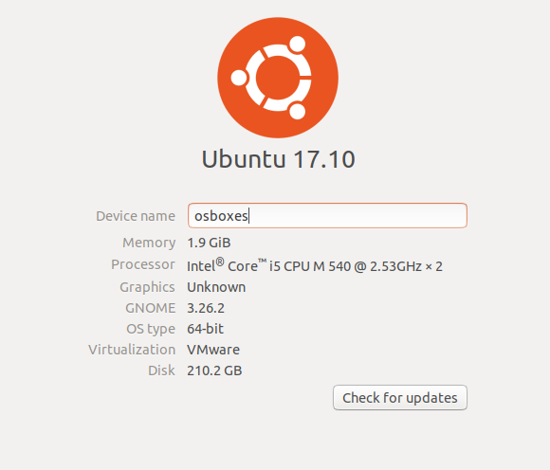

## Install using the commands

Before installing the WIMS you need run 2 commands

**apt-get update**

**apt-get upgrade**  --show-upgrade

These 2 commands will update your operation system and prepare initially machine.

And after successful run these commands run the command written below.

**apt-get install** wims

This will install the latest wims package available on Debian: https://packages.debian.org/en/stretch/wims

Via this, WIMS will be installed here: **/ var / lib / wims**

**Note: before run this command your machine need to be installed the apache2 using below command.**

sudo apt-get install apache2

Whether you are using automatic or manual installation, we recommend you upgrade to WIMS Configuration.

## WIMS configuration

By default, it would be installed in **/var/lib/wims.**

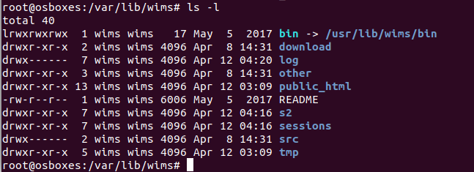

Open a browser on the machine where you have installed WIMS and go this address

http://127.0.0.1/wims/

And you will see the webpage like this.

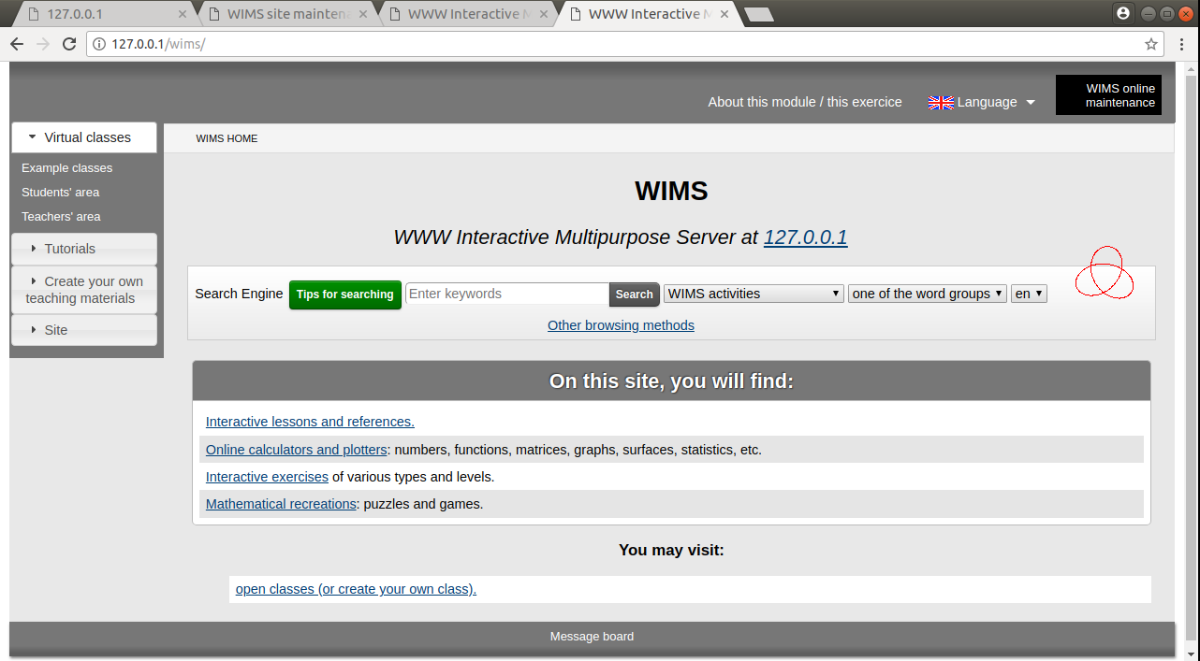

If you want login with administrator, there is black button “WIMS online maintenance” in the top right corner and you will see below page.

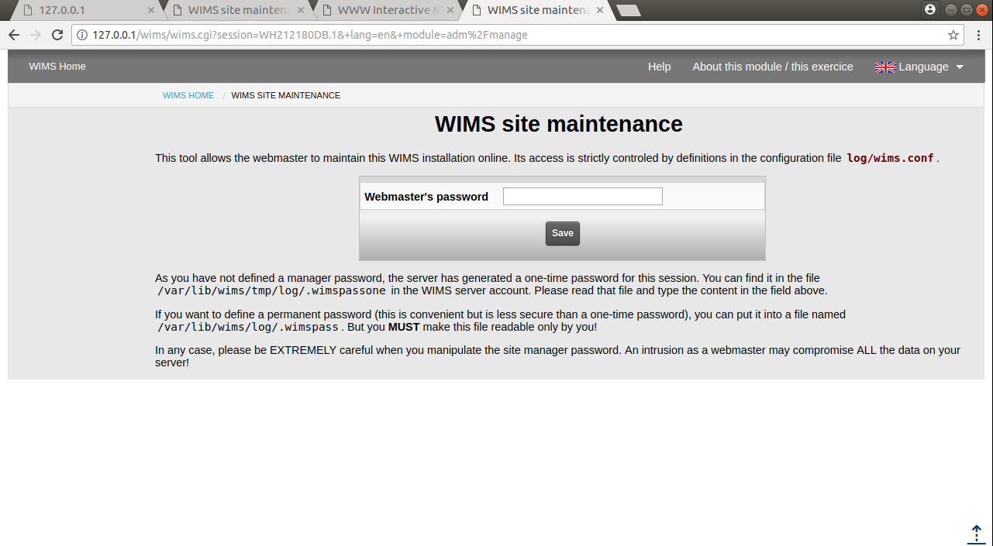

For login this page you can use temporarily password and permanent password.

Temporarily password located in **/var/lib/wims/tmp/log/.wimspassone**

If you want to define a permanent password (this is convenient but is less secure than a one-time password), you can put it into a file named /var/lib/wims/log/.wimspass. But you MUST make this file readable only by you!

## API service

To connect WIMS from another server or application, we used Protocol for WIMS direct connection. For any documentation you have to go <http://127.0.0.1/wims/wims.cgi?module=adm/raw&job=help> this link. As mentioned there, first, we need to declare the connection file under **/var/lib/wims/log/classes/.connections/** directory and create a new customized file for you.

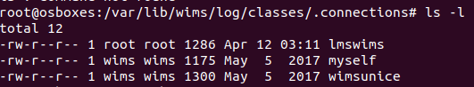

And I attached **lmswims** connection file with this documentation.

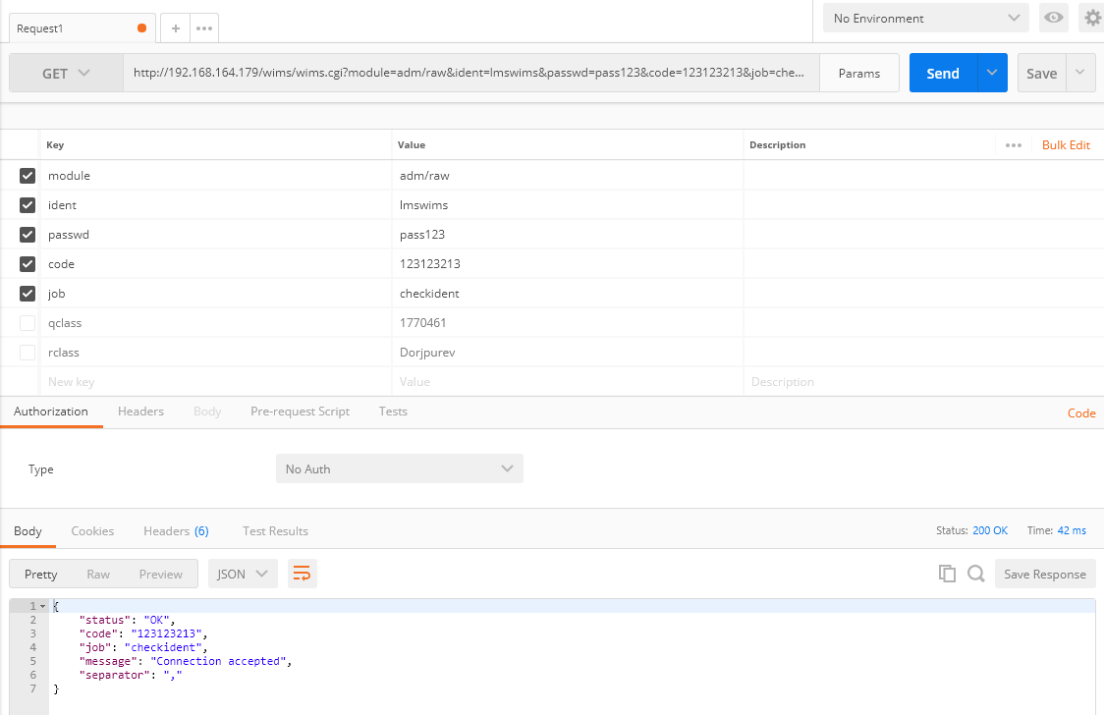

As we see the above generated GET HTTP request, we succeed to connect our virtual WIMS and connection accepted.

# References

1. Installation documentation by WIMS Edu : https://wiki.wimsedu.info/doku.php?id=installation:debian:auto